Worksheet 2.2

Student Name: Sahil Kaundal UID: 21BCS8197

Branch: CSE (Lateral Entry) Section/Group:20BCS-807_B Semester: 4th Date of Performance: 25/03/2022

Subject Name: Programming in Python Lab Subject Code: 20CSP-259

1. Aim/Overview of the practical:
2. Write a Python program to get a list, sorted in increasing order by the last element in each tuple from a given list of non-empty tuples
3. Write a Python program to print a specified list after removing the 0th, 4th and 5th elements, Sample List : ['Red', 'Green', 'White', 'Black', 'Pink', 'Yellow'],Expected Output : ['Green', 'White', 'Black']

1. Task to be done/ Which logistics used:



* Python program to get a list, sorted in increasing order by the last element in each tuple from a given list of non-empty tuples

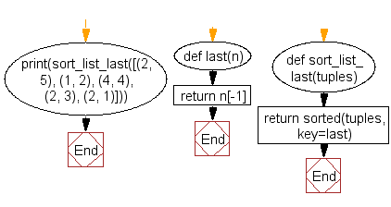

* Python program to print a specified list after removing the 0th, 4th and 5th elements, Sample List : ['Red', 'Green', 'White', 'Black', 'Pink', 'Yellow'],Expected Output : ['Green', 'White', 'Black']

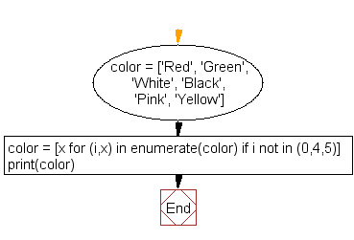

1. Steps for experiment/practical/Code:

* Python program to get a list, sorted in increasing order by the last element in each tuple from a given list of non-empty tuples

def last(n): return n[-1]

def sort_list_last(tuples):

return sorted(tuples, key=last)

print("Sorted list is.")

print(sort_list_last([(2, 5), (1, 2), (4, 4), (2, 3), (2, 1)]))

print(sort_list_last([(3, 6), (1, 2), (5, 3), (8, 9), (6, 2)]))

* Python program to print a specified list after removing the 0th, 4th and 5th elements, Sample List : ['Red', 'Green', 'White', 'Black', 'Pink', 'Yellow'],Expected Output : ['Green', 'White', 'Black']

color = ['Red', 'Green', 'White', 'Black', 'Pink', 'Yellow']

color = [x for (i,x) in enumerate(color) if i not in (0,4,5)]

print("After removing the 0th, 4th and 5th elements are: ")

print(color)

1. Result/Output/Writing Summary:

* Python program to get a list, sorted in increasing order by the last element in each tuple from a given list of non-empty tuples

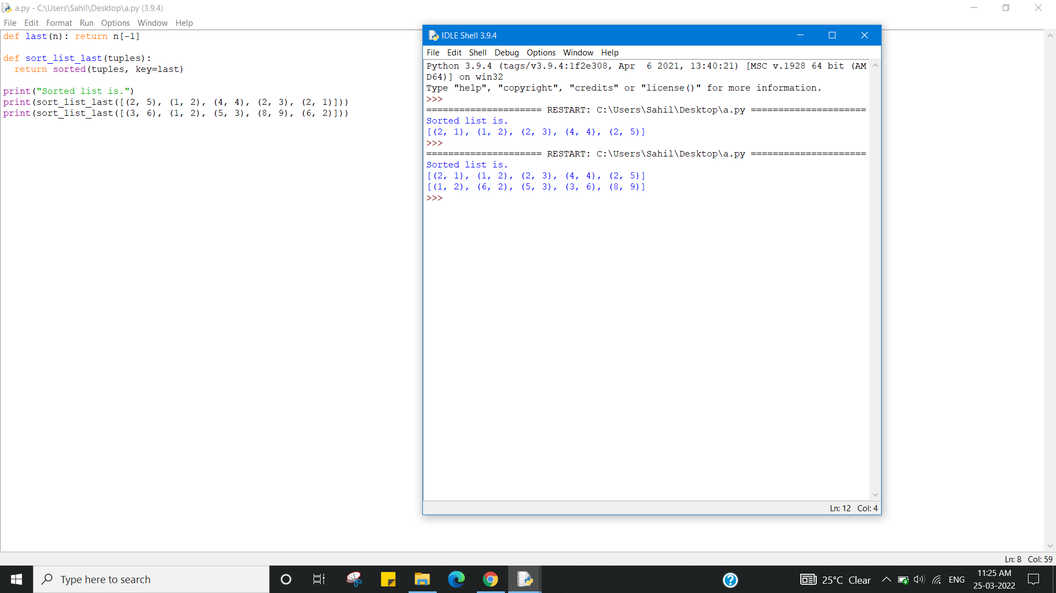

* Python program to print a specified list after removing the 0th, 4th and 5th elements, Sample List : ['Red', 'Green', 'White', 'Black', 'Pink', 'Yellow'],Expected Output : ['Green', 'White', 'Black']

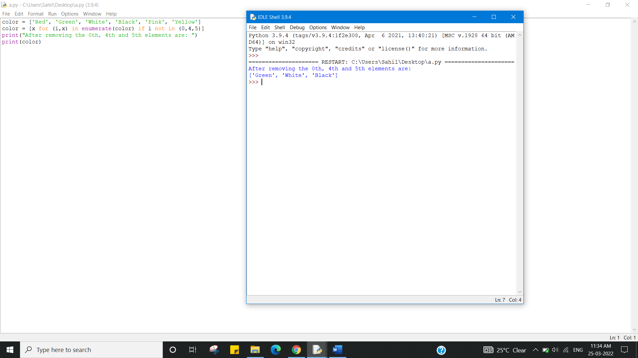

Learning outcomes (What I have learnt):

1. Python program to get a list, sorted in increasing order by the last element in each tuple from a given list of non-empty tuples
2. Python program to print a specified list after removing the 0th, 4th and 5th elements, Sample List : ['Red', 'Green', 'White', 'Black', 'Pink', 'Yellow'],Expected Output : ['Green', 'White', 'Black']

Evaluation Grid (To be created as per the SOP and Assessment guidelines by the faculty):



|  |  |  |  |
| --- | --- | --- | --- |
| Sr. No. | Parameters | Marks Obtained | Maximum Marks |
| 1. |  |  |  |
| 2. |  |  |  |
| 3. |  |  |  |